Virtual field emission scanning electron microscope (fesem)

Aggregates of amphiphile molecules
Source: http://www-vcbio.sci.kun.nl/eng/fesem/applets/amfifielen
Surf to the source to use the fesem simulator microscopic objects and to view information on the principles of this scanning electron microscope.

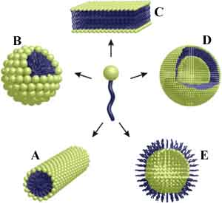
Amphiphiles
Hydrophilic (hydros = water; philic = loving) molecules dissolve well in water (a polar solvent), whereas hydrophobic (waterminding) molecules dissolve best in an apolar solvent. Molecules that consist of both a hydrophobic and a hydrophilic part are called amphiphiles (amphi = both). Amphiphile molecules orientate their domain with the highest affinity for the solvent toward that solvent, while the other part of the molecule turns to avoid contact with the solvent. In this way amphiphilic molecules align according to well-defined patterns and give rise to pluriform aggregates. The shape (=morphology) of the aggregates is determined by the ratio between the size of the hydrophilic and the hydrophobic part as well as the nature of the solvent. Scanning electron microscopy and other techniques have revealed various morphologies: micellar rods, micelles, bilayers, vesicles and inverted aggregates.
The washing property of soap is based on amphiphiles that interfere between water and (fatty) dirt. Amphiphiles also form the main part of the cell membranes that serves to delimit and protect cellular compartments.

Spherical aggregates of polystyrene-polyisocyanides: "microcontainers"
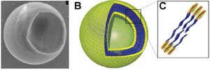
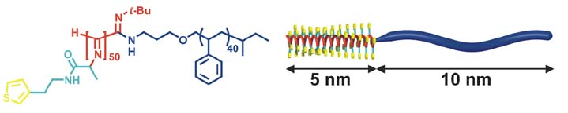
The bead-like aggregates shown in this demonstration are made of polystyrene polyisocyanides (abbreviated PS-PIAT; see formula) that have been synthetized at the Department of Organic Chemistry (KUN). The spherical aggregates have been obtained by dissolving the PS-PIAT polymer in an organic solvent (tetrahydrofuran) and injecting the mixture into water. The aggregates resemble vesicles, since they consist of a membrane bilayer sheath and are hollow in the centre.
The vesicles have a diameter of about 1.5 µm, are very stable and retain their shape after air-drying. It was demonstrated that dye molecules and even enzymes could be included inside these vesicles. The micro-vesicles system (microcontainers) is particularly interesting, because it offers perspectives for applications as microreactors.
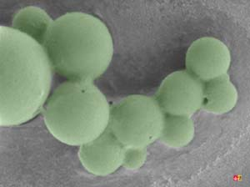
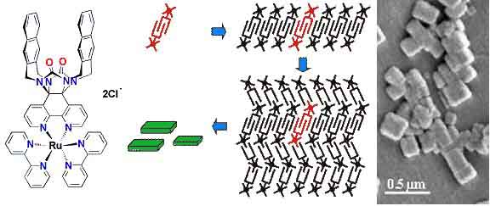
Self-assembling artifical receptors: "molecular clips"
Other amphiphiles that are synthesized and studied at the departments of Organic Chemistry and Solid State Physics 2 are the so-called "molecular clips". They are artifical receptors that consist of a U-shaped hydrophobic cavity and a hydrophilic ruthenium tris(bipyridine) complex (structure formula left). In water, these molecules self-assemble by filling up each other's cavities (central diagram). Eventually, rectangular aggregates are formed (fesem image right; scientist: H. Elemans), which contain thousands of molecules and which all have a well-defined shape and a similar size.
The ordering of the molecules was confirmed by X-ray powder diffraction and high resolution Nuclear Magnetic Resonance techniques. The arrangement of the chromophoric ruthenium complexes renders these aggregates interesting for further development as photoactive elements.
More information: J.A.A.W. Elemans, A.E. Rowan, and R.J.M. Nolte, J. Am. Chem. Soc. 2002, 124, 1532-1540).

People and copyright
(Ex)Managers of the cryo-FESEM: Geert-Jan Janssen and Huub Geurts
Technical specialist Jeol: Rob Fase
Development of the FESEM simulator: Jeroen van Beurden
Web development: Remco Aalbers
Initiation + funds application virtual FESEM project: Jan Derksen
Imaging-tutorials: Dennis Vriezema, Hans Elemans and Elisabeth Pierson
Contact: e.pierson@science.ru.nl
Copyright: University of Nijmegen = Radboud University Nijmegen

