Virtual field emission scanning electron microscope (fesem)
Flea of a dog
Source: http://www-vcbio.sci.kun.nl/eng/fesem/applets/vlo
Surf to the source to use the fesem simulator on this and other objects, to download a high-resolution image or to view information on the principles of the microscope.

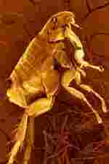
Biology of the flea
About 200 different species of fleas exist worldwide. Mature fleas feed with blood from the skin of their host: pets, people, and wild animals like skates, fishes, and birds. The best known species are the cat flea Ctenocephalides felis felis, which can also bite dogs and humans), the dog flea (Ctenocephalides canis) and the specific human flea Pulex irritans). These fleas belong to the group of the wingless insects (Phylum: Arthropoda; Class: Insecta; Order: Siphonaptera; Suborder: Pulicidae).
Fleas can transmit germs to their host, like eggs of tapeworms. The rat flea (Xenopsylla cheopsis) was the transmission vector of the bubonic plague bacteria (Yersinia pestis) that caused billions of victims in the Middle Ages.
Life cycle of a pet flea
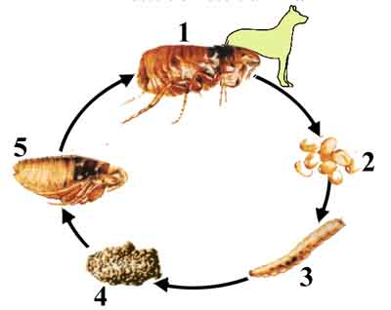
Fleas of dogs and cats follow a life cycle that takes in the average three to six weeks, although fleas may stay alive for about 1 year. Effective control of flea infestation aims to interrupt the life cycle.
1. Adult flea
Adult fleas (1.5 - 6 mm) can remain attached to their host thanks to extensions (setae) en hooks. Before sucking blood (about 150x its own body weight), the flea pierces the skin of its host with its mouth and injects saliva that contains an anti-blood-clotting agent. The saliva may cause of an allergic skin reaction. After the first blood uptake, fleas undergo a metabolic change and need regularly new blood meals to survive (they become an obligate parasite). After mating females can lay up to 40 eggs a day.
2. Eggs
The eggs (about 0.5 mm) develop best in a warm and humid environment. The eggs, which are smooth and can easily fall on the floor, hatch between 1 and 10 days of being deposited on the host.
3. Larvae
The larvae that emerge from the eggs mind light and extreme temperatures. Dark, sheltered dust nests like carpets, rugs and splits in wooden parket are ideal habitats for larvae. They feed on organic debris (e.g. crumbles and skin scales) or also on feces from adult fleas. The larvae go through three stages of instars.
4. The pupae stage
The adult larvae (about 5 mm in length) envelop themself with a sticky cocoon and turn into pupae. The pupay may may remain dormant for monthes inside the protective cocoon.
5. Young fleas
The young fleas (in 5 dissected out of the cocoon) often stay inside the cocoon until they percept a favorable trigger, like a raise in temperature or carbon dioxide level of the surroundings, vibrations or changes in light pattern. Then, they crawl out of the cocoon within a couple of seconds and use their powerful posterior legs to jump on their host.

People and copyright
Manager of the cryo-FESEM: Huub Geurts
Technical specialist Jeol: Rob Fase
Development of the FESEM simulator: Jeroen van Beurden
Web development: Remco Aalbers
Initiation + funds application virtual FESEM project: Jan Derksen
Imaging-tutorials: Elisabeth Pierson
Contact: hpmg@sci.kun.nl or epierson@sci.kun.nl
Copyright: University of Nijmegen

